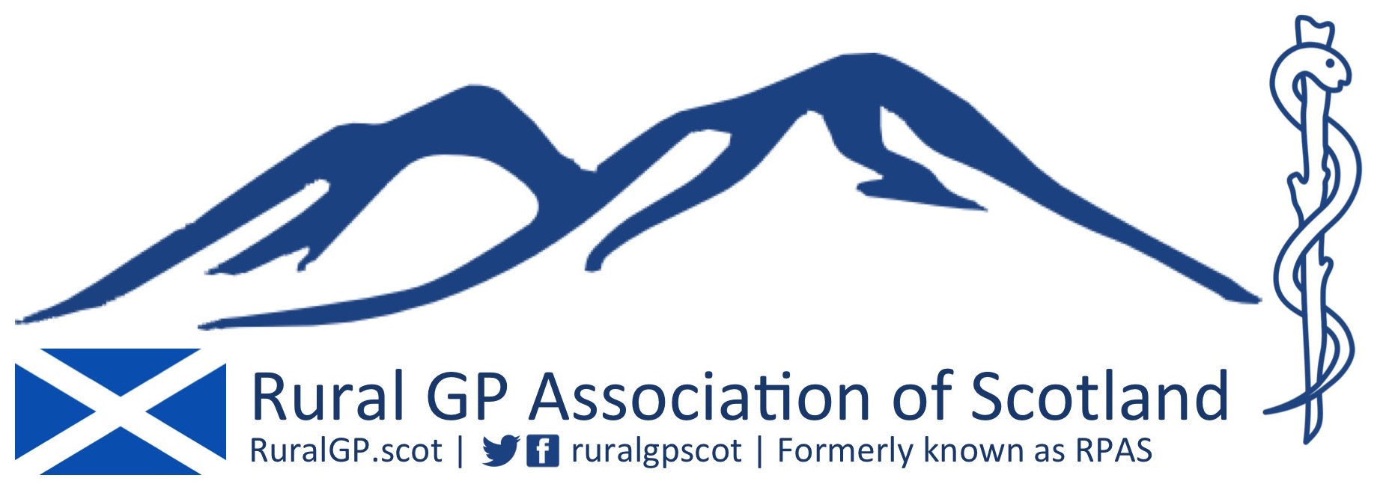

RGPAS Student/Travel Scholarships January 2017

Background

RGPAS exists to act as a forum to further the educational and professional needs of rural and remote GPs in Scotland. In addition, we recognise the benefits of supporting undergraduate medical students to experience remote and rural practice – including during elective placements.

It was agreed at the 2016 RGPAS AGM that we would allow £3000 of RGPAS Educational Trust money to fund a number of scholarships aimed at both RGPAS members and to encourage/enable students to experience rural practice in Scotland for their electives.

Student Scholarships

In January 2016 there will be five scholarships available, each to a value of £200.
- This can be used to fund accommodation, travel or other associated costs. Receipts may be requested at the committee’s discretion.
- The student must be doing their elective at a Scottish rural practice where at least one GP is a member of RGPAS. The student must be at least 20 miles away from their home address.
- Electives may take place at any time of the year, and be for a minimum of 4 weeks.
- The student must be an undergraduate medical student from a Scottish university.
- The student should submit either a 500 word report or a video (of 3 minutes or more) about their experience within 2 months of the end of the elective. They may be asked to present at the next RGPAS conference too, if they are able.
- Details of successfully awarded scholarships will be made available to RGPAS members, and also via the RuralGP.scot and RuralGP.com websites.

GP Travel Scholarships

In January 2017 there will be three travel scholarships available. Nominally each of these will be worth £500, however some flexibility may be applied to support applications which require more or less than this amount.

- The applicant will be a member of RGPAS for at least 3 months prior to application. They will be a GP or a GP Trainee (at any stage of ST training) currently practising in Scotland.
- RGPAS Committee members are eligible to apply.
- The recipient should attend a conference in a country other than the UK. There will be a preference for activities that foster new relations with other country/world organisations such as WONCA or rural GP associations.
- The money may be used for travel, accommodation or locum costs associated with attending a conference, event or experience in rural practice
- The recipient should submit either a 500 word report or video (of 3 minutes or more) about their experience within 2 months of the end of the travel period. They may be asked to present at the next RGPAS conference too, if they are able.
- Details of successfully awarded scholarships will be made available to RGPAS members, and also via the RuralGP.scot and RuralGP.com websites.

How to Apply

- Please complete the attached form, and submit this by email to hello@ruralgp.scot
- Closing date: 6pm Friday 27th January 2017
- The RGPAS committee will meet virtually, to discuss and judge the applications. Their decision will be final. They may decide not to award all available scholarships. The decision of the committee will be confirmed to successful applicants by Friday 10th February 2017 at latest.

This process will be reviewed at least on an annual basis.

David Hogg
Chair, RGPAS

Issued: 19th December 2016

RGPAS Student Elective Scholarship 2017

Application Form

Name:

Contact Address:

Phone:

Email:

University & Year:

Matriculation Number:

________________________________________________________________________

Elective Dates:

Elective Placement (Location & Supervisor):

Please outline why you have chosen this elective placement. What are your aims & objectives? (up to 300 words)

Have you been allocated any other funding for this project?

How would you use the scholarship? Please outline how the money would be spent.

I confirm that I have read the Scholarship Guidelines and that I will submit a report as outlined in the Guidelines to RGPAS on completion of the elective placement.

Signed: Date:
(or type name if
signature not possible):

Please save this word file, and return it by email to: hello@ruralgp.scot

You will receive confirmation of receipt within 5 days.

RGPAS Travel Scholarship 2017

Application Form

Name:

Contact Address:

Phone:

Email:

GP Practice:

GMC Number:

________________________________________________________________________

Travel Dates:

Project Details. (Please outline what this travel period will involve. What are your aims & objectives? What benefits will it bring to you, your GP practice and/or Scottish Rural Practice? - up to 300 words).

Have you been allocated any other funding for this project?

How would you use the scholarship? Please outline how the money would be spent.

I confirm that I have read the Scholarship Guidelines and that I will submit a report as outlined in the Guidelines to RGPAS on completion of the travel placement.

Signed: Date:
(or type name if
signature not possible):

Please save this word file, and return it by email to: hello@ruralgp.scot

You will receive confirmation of receipt within 5 days.

